**EX.NO:6 DATE:30/10/2024**

**Reg.no:220701022**

**INTRODUCTION TO PROLOG**

**AIM:**

To learn PROLOG terminologies and write basic programs.

**TERMINOLOGIES:**

1.Atomic Terms: -

Atomic terms are usually strings made up of lower- and uppercase letters, digits, and the underscore, starting with a lowercase letter.

Ex: dog ,ab_c_321

1. Variables: -

Variables are strings of letters, digits, and the underscore, starting with a capital letter or an underscore.

Ex: Dog Apple_420

1. Compound Terms: -

Compound terms are made up of a PROLOG atom and a number of arguments (PROLOG terms, i.e., atoms, numbers, variables, or other compound terms) enclosed in parentheses and separated by commas. Ex: is_bigger(elephant,X) f(g(X,_),7)

1. Facts: -

A fact is a predicate followed by a dot.

Ex: bigger_animal(whale). life_is_beautiful.

5.Rules: -

A rule consists of a head (a predicate) and a body (a sequence of predicates separated by commas). Ex: is_smaller(X,Y):-is_bigger(Y,X).

aunt(Aunt,Child):-sister(Aunt,Parent),parent(Parent,Child).

**SOURCE CODE:**

**KB1:**

woman(mia). woman(jody). woman(yolanda). playsAirGuitar(jody). party.

Query 1: ?-woman(mia).

Query 2: ?-playsAirGuitar(mia).

Query 3: ?-party.

Query 4: ?-concert.

**OUTPUT:**

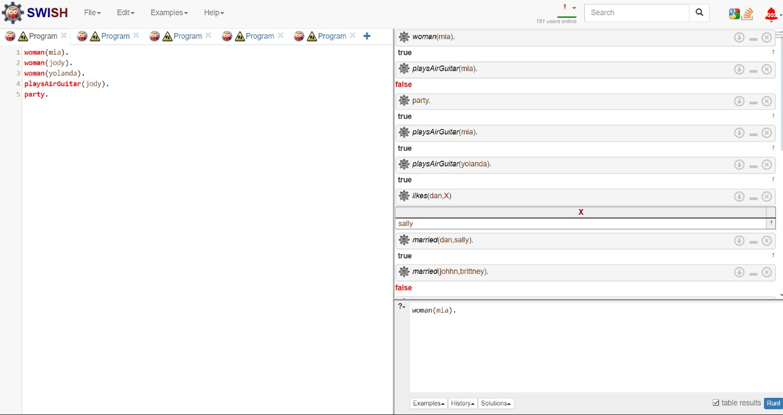

**KB2:** happy(yolanda). listens2music(mia).

Listens2music(yolanda):-happy(yolanda). playsAirGuitar(mia):-listens2music(mia). playsAirGuitar(Yolanda):-listens2music(yolanda).

**OUTPUT:**

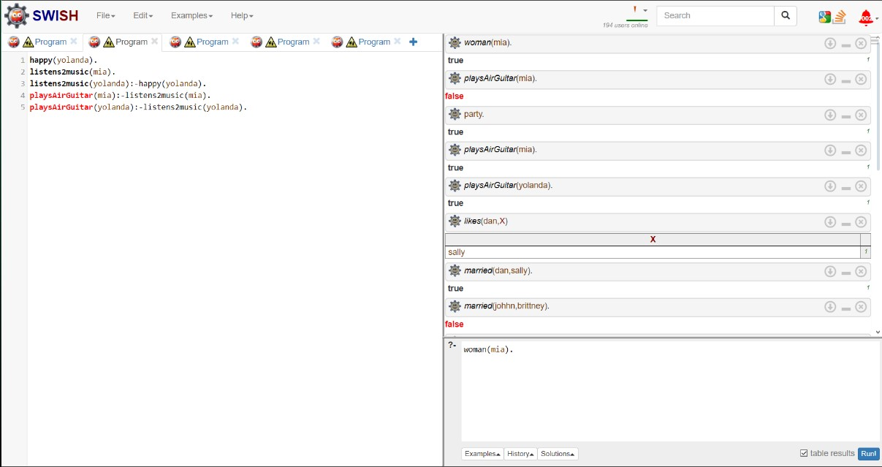

**KB3:** likes(dan,sally). likes(sally,dan). likes(john,brittney). married(X,Y) :- likes(X,Y) , likes(Y,X). friends(X,Y) :- likes(X,Y) ; likes(Y,X).

**OUTPUT:**

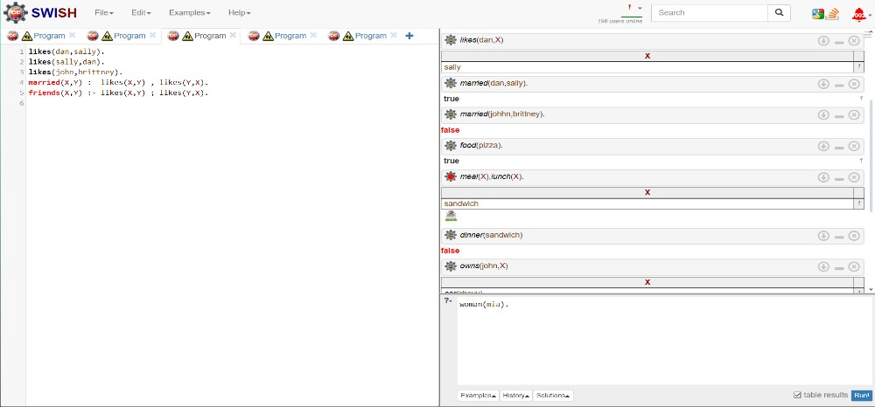

**KB4:** food(burger). food(sandwich). food(pizza). lunch(sandwich). dinner(pizza). meal(X): -food(X).

**OUTPUT:**

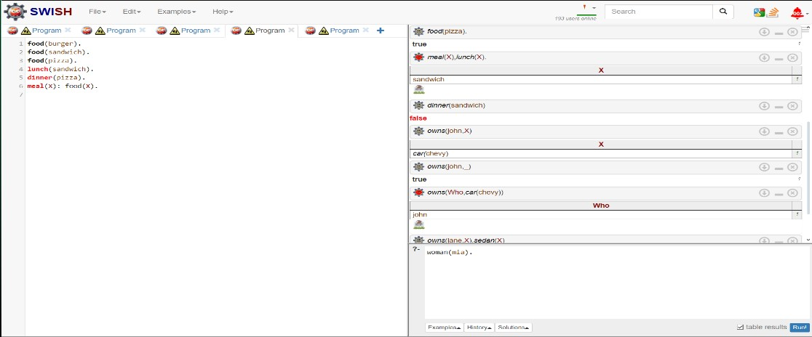

**KB5:**

owns(jack,car(bmw)). owns(john,car(chevy)). owns(olivia,car(civic)). owns(jane,car(chevy)). sedan(car(bmw)). sedan(car(civic)). truck(car(chevy)).

**OUTPUT:**

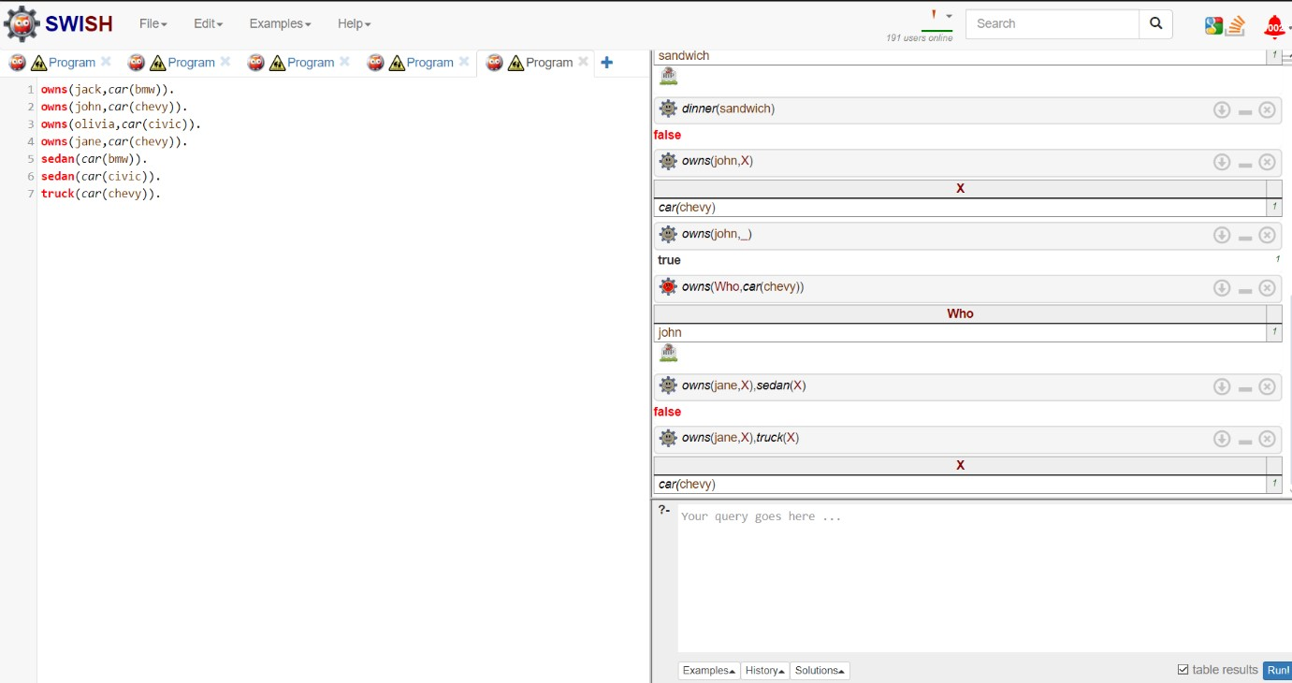

**RESULT:**

Thus, the basic prolog programs have been implemented successfully.